CSE 2320 Notes 14: Graph Representations and Search

(Last updated 11/7/26 11:21 PM)

CLRS 22.1-22.5

14.A. Graph Representations

Adjacency Matrices – for dense 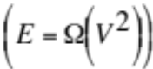 classes of graphs

(“A sparse graph is one whose number of edges is reasonably viewed as being proportional to its number of vertices” http://dl.acm.org.ezproxy.uta.edu/citation.cfm?id=2492007.2492029 )

Directed Graph
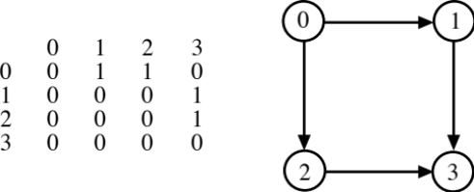

Diagonal: Zero edges allowed for paths? (reflexive, assumed self-loops)

Undirected Graph
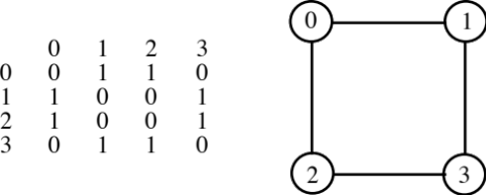

Which is more general? Time to query for presence of an edge?

Adjacency Lists – for sparse 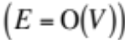 classes of graphs

Directed

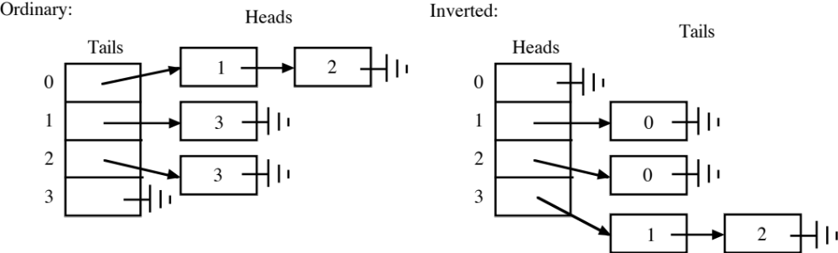

1. Time to query for presence of an edge?
2. Can convert between ordinary and inverted in Θ(V + E) time, assuming unordered lists.
3. These two structures can be integrated using both tables and a common set of nodes with two linked lists through each node.

Undirected:

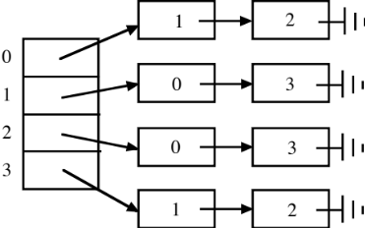

Weights – Used to represent distances, capacities, or costs.

Entries in adjacency matrix.

Field in nodes of adjacency list.

Compressed Adjacency Lists – useful “pointerless” representation for sparse, static graphs (not in book,
https://dl-acm-org.ezproxy.uta.edu/citation.cfm?id=3230485 discusses similar Compressed Sparse Row format)
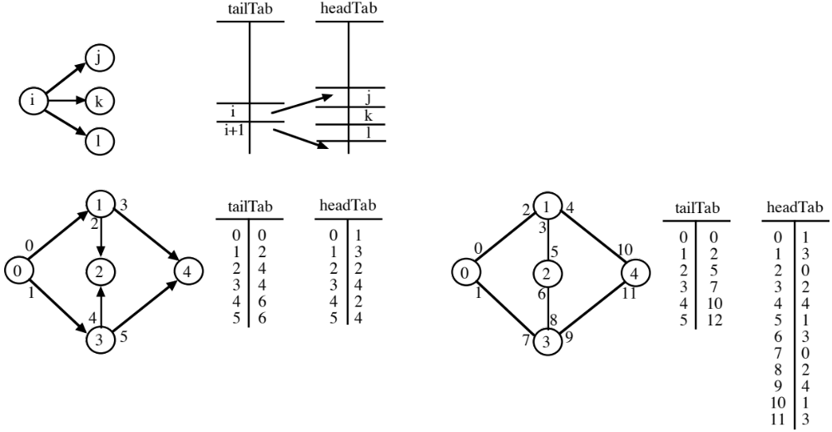

To process the edges with vertex i as the tail:

for (j=tailTab[i]; j<tailTab[i+1]; j++)
< Process edge i → headTab[j] >

Time to query for presence of an edge?
14.B. Breadth-First Search (Traversal) – Queue-Based

1. Assume input is directed graph with path from source to every vertex

Source vertex is designated (assume 0)

Vertex colors and interpretations

a. White – undiscovered/unvisited

b. Gray – presently in queue

c. Black – completely processed (all adjacent vertices have been discovered)

Possible outputs:

a. BFS number (assigned sequentially)

b. Distance (hops) from source

c. Predecessor on BFS tree

Label node with a/b/c

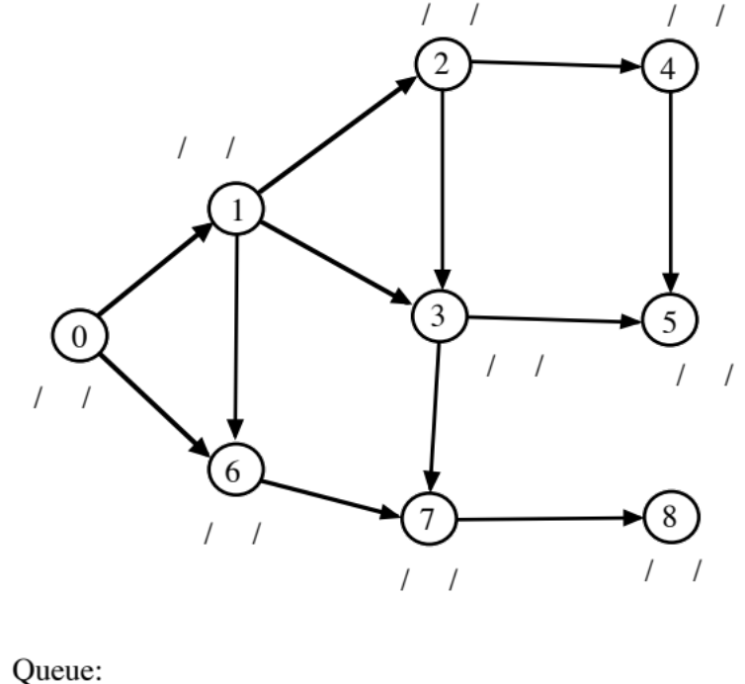

Time:

a. Initialization (Θ(V)) b. Process each edge once (Θ(E))

2. Remove assumption regarding path from source to every vertex:

Initialize all vertices as white
for (i=0; i<V; i++)
if vertex i is white
Call BFS with i as source

Can also use on undirected graph.

Number of BFS calls (“restarts”) is the number of connected components.

Each edge is processed twice, but each vertex is discovered once.

Diameter of Tree – Application of BFS

1. Choose arbitrary source for BFS. Run BFS and select any vertex X at maximum distance (“hops”) from source (e.g. last vertex removed from queue).

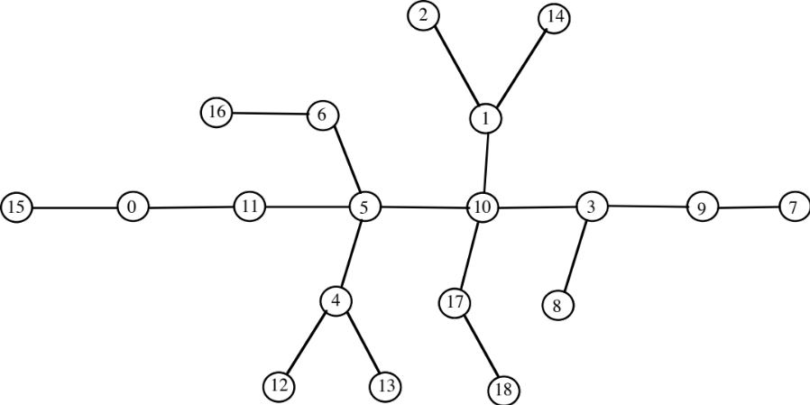

2. Run second BFS using X as source. X will be at one end of a diameter and any vertex at maximum distance from X can be the other end of the diameter.

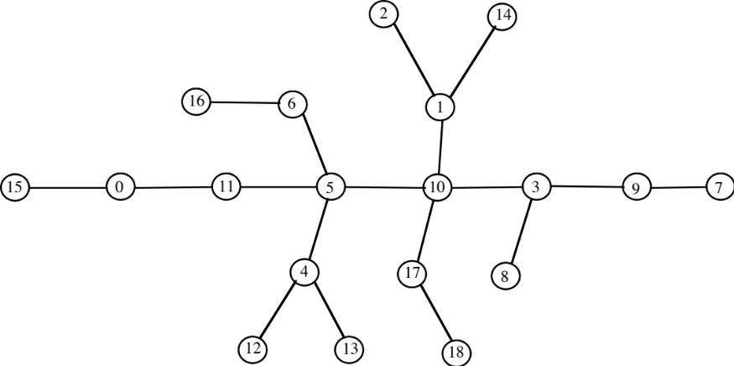

Takes Θ(V + E) time.
14.C. Depth-First Search (Traversal) – Stack/Recursion-Based

Usually applied to a directed graph.

Vertex colors and interpretations

a. White – undiscovered (neither time assigned, i.e. value of both is still -1)

b. Gray – presently in stack (only discovery time assigned)

c. Black – completely processed (all adjacent vertices have been discovered, both times assigned)

Possible outputs:

a. Discovery (preorder) time

b. Finish (postorder) time

c. Predecessor on DFS tree

d. Edge types

Processing:

a. Change vertex from white → gray the first time it enters stack and assign discovery time (using counter).

b. When a vertex (and pointer to its adjacency list) is popped, check for next adjacent vertex and push this vertex again.

c. If no remaining adjacent vertices, then change vertex from gray → black and assign finish time.

Like BFS, DFS takes Θ(V + E) time.

Relationship between vertex and adjacent vertex determines the edge type.

a. Unvisited (white) ⇒ tree edge

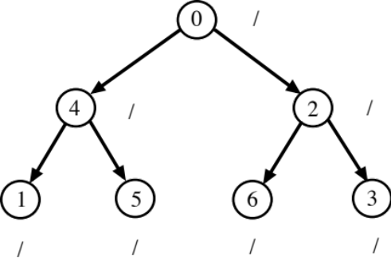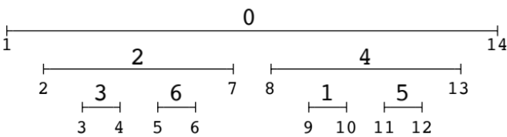
b. On the stack (gray indicating ancestor) ⇒ back edge

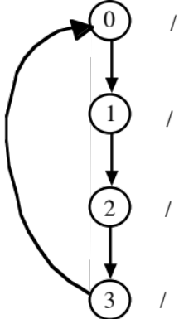

c. Previously visited, not on stack (black), but known to be descendant ⇒ forward edge (AKA down edge)

1. Find path of tree edges? TEDIOUS

2. discovery(tail) < discovery(head)

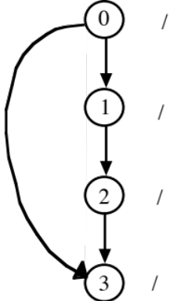

d. None of the above . . . Not on stack (black) and not a descendant ⇒ cross edge

Test using discovery(tail) > discovery(head)

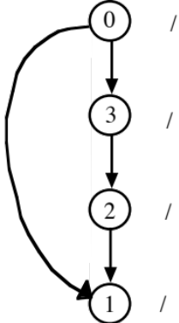
Example:
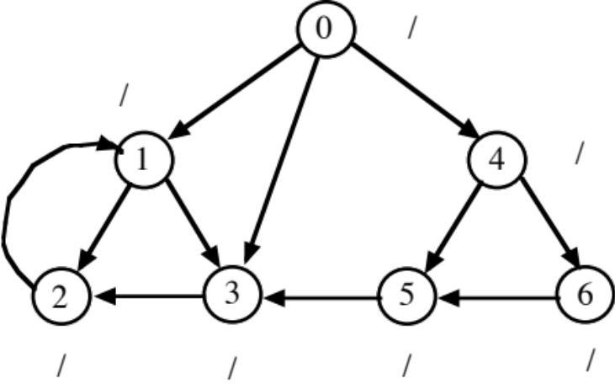

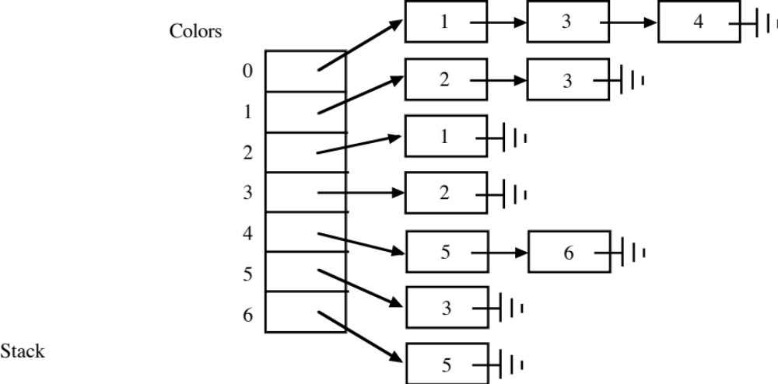

Undirected – Can’t have cross or forward edges:

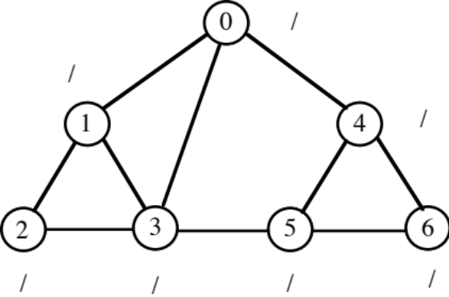

Restarts – handled like BFS

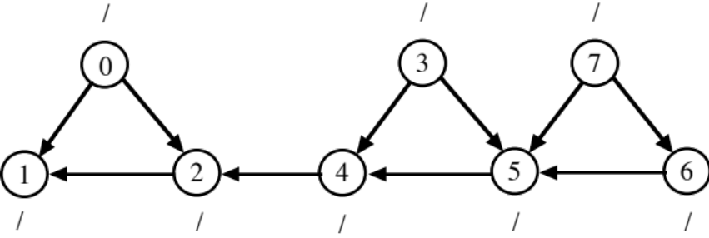

Example – available from course web page ( http://ranger.uta.edu/~weems/NOTES2320/dfsDir.c
http://ranger.uta.edu/~weems/NOTES2320/dfs1.dat )

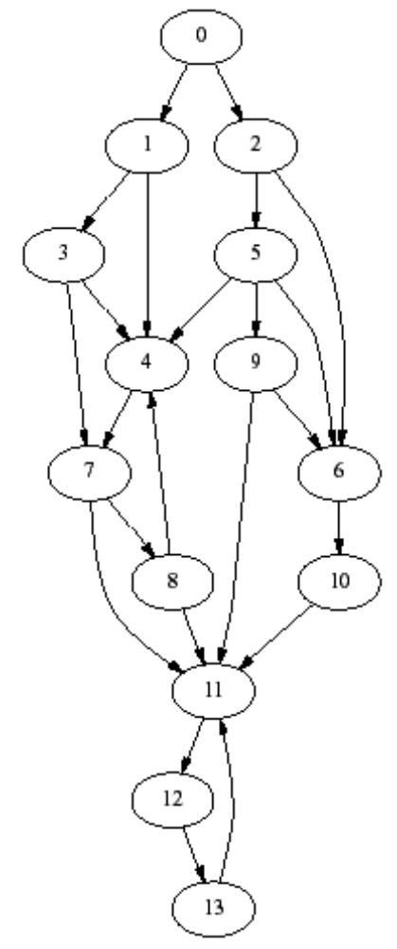

Vertex discovery finish predecessor
0 1 28 -1
1 2 17 0
2 18 27 0
3 3 16 1
4 4 15 3
5 19 26 2
6 20 23 5
7 5 14 4
8 6 13 7
9 24 25 5
10 21 22 6
11 7 12 8
12 8 11 11
13 9 10 12
Edge Tail Head Type
0 0 1 tree
1 0 2 tree
2 1 3 tree
3 1 4 forward
4 2 5 tree
5 2 6 forward
6 3 4 tree
7 3 7 forward
8 4 7 tree
9 5 4 cross
10 5 6 tree
11 5 9 tree
12 6 10 tree
13 7 8 tree
14 7 11 forward
15 8 4 back
16 8 11 tree
17 9 6 cross
18 9 11 cross
19 10 11 cross
20 11 12 tree
21 12 13 tree
22 13 11 back

14.D. Topological Sort of a Directed Graph

Linear ordering of all vertices in a graph.

Vertex x precedes y in ordering if there is a path from x to y in graph.

Apply DFS:

1. Back edge ⇔ graph has a cycle (no topological ordering).

2. When vertex turns black, insert at beginning of ordering (ordering is reverse of finish times).

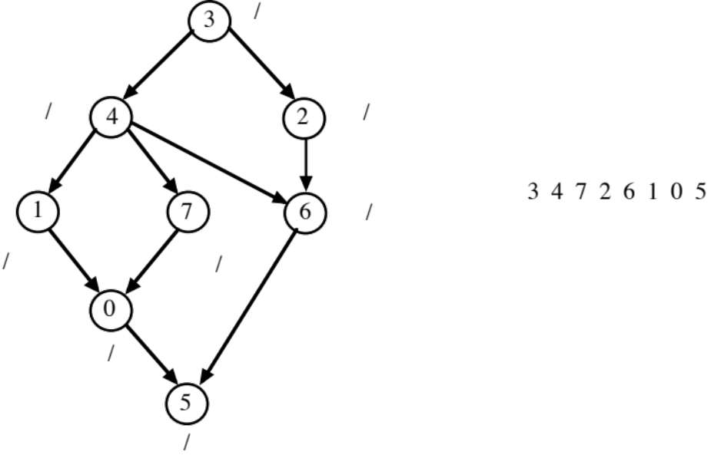

14.E. Strongly Connected Components

(Kosaraju’s method, http://ranger.uta.edu/~weems/NOTES2320/dfsSCC.c )

Equivalence Relation – definition (reflexive, symmetric, transitive)

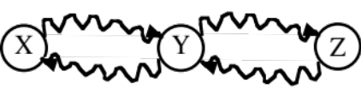

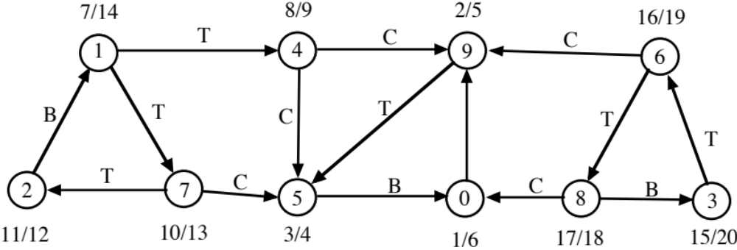

1. Perform DFS. When vertex turns black ⇒ insert at beginning of list. (3 6 8 1 7 2 4 0 9 5)

2. Reverse edges. (Does not change the strongly connected equivalence relation)

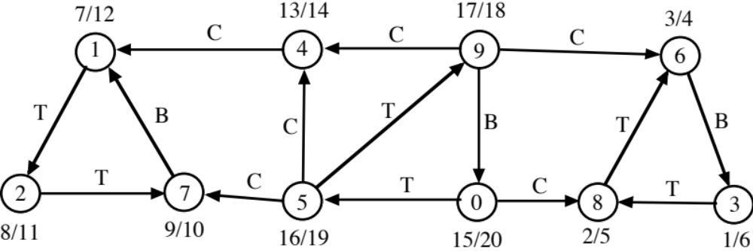

3. Perform DFS, but each restart chooses the first white vertex in list from 1. Vertices discovered within the same restart are in the same strong component.

Observation: If there is a path from x to y and no path from y to x, then finish(x) > finish(y) (first DFS).

This implies that the reverse edge (y, x) corresponding to an original edge (x, y) without a “return path” will be a cross edge during 2nd DFS. The head vertex y will be in a SCC that has already been output.

Takes Θ(V + E) time.

